Here are some colors that are common / present in Wet World, taken from our year of videos.

DO NOT USE A COLOR PAPER WITH THESE COLORS.

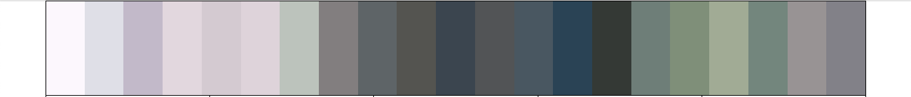

It is highly recommended to avoid orange, blue, green, white and black.

Pink, purple, shades of red and other colors may still work, as well as orange, depending on the background.

Do not use grey or different shades of the above color, as light conditions may make them visually darker or lighter.

A full RGB list of the blacklisted colors, as well as the code used to generate the above image can be found in the GitHub.

Last updated 25/11/2025 by LJ.

